[2019 Steering Calculations.xlsx - Google Sheets](https://docs.google.com/spreadsheets/d/1Y2ApV_XOPfjRkaZcw6suEL1fR_TUZgcm/edit?gid=1971154106" \l "gid=1971154106)  
<https://docs.google.com/spreadsheets/d/1cl9DuK5snweZqPJ_IoHzqHHEUraEJkfjxXml6t9tQyA/edit?gid=0#gid=0>  
[2022 Braking calculations Bhupesh - Google Sheets](https://docs.google.com/spreadsheets/d/1CBtg8vDduhEr2xxG9ewhptohvVxjpXaHpi0ckFJqeSw/edit?gid=0#gid=0)

[Copy of E59_UTS_Spec_Sheet.xls - Google Sheets](https://docs.google.com/spreadsheets/d/1Iyz9X_exPuxsMpyxmD5vY5gwERPPAJJw/edit?gid=764858917#gid=764858917)

Mechanical Trail:

Mechanical trail is the horizontal distance between the tire contact patch (where the tyre touches the ground) and the point where the steering axis intersects the ground, measured perpendicular to the steering axis. This dimension helps define the amount of self-aligning torque or feedback the driver feels through the steering wheel.

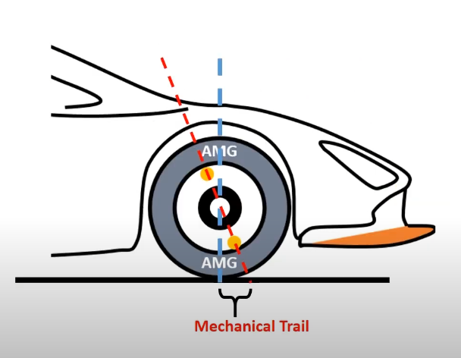

(https://www.automotorgarage.com/post/caster-angle-mechanical-trail-how-does-the-steering-wheel-automatically-returns-to-its-center)

Using

Tyre radius: 457.5 /2 = 228.5m

Caster Angle of 6

Tm = 0.197m

Bit confused with Mechanical Trail, in 2019 excel, it’s 0.005.

1. **Pinion Torque:** Pinion torque is the rotational force applied to the pinion gear by the steering input, whether from a driver or an autonomous actuator. This torque (measured in Newton-meters, Nm) turns the pinion gear, which then moves the steering rack in a linear direction. The relationship between the pinion torque (T) and the force on the rack (F_rack) is determined by the pinion’s geometry, as the rack is driven by the pinion’s circular motion.
2. **Force on the Rack (F_rack):** The force on the rack can be calculated from the pinion torque using the formula:

Frack​= Tpinion​​/r pnion

Where:

* + ( F_{rack} ) = Linear force acting along the rack (in Newtons, N)
  + ( T_{pinion} ) = Pinion torque (in Newton-meters, Nm)
  + ( r_{pinion} ) = Effective pinion radius (in meters, m)

**Example Calculation:** Given:

* + Pinion Torque (( T_{pinion} )) = 14.5 Nm
  + Pinion Radius (( r_{pinion} )) = 0.014 m

The force on the rack would be:

Frack​= 14.5Nm​/0.014m =1035.71N

This value is very close to the total rack lateral force (1036.3 N) you previously provided.

1. **Force along the Shaft (Steering Column Force):** The force along the steering column (shaft) depends on the mechanical advantage between the steering wheel and the pinion gear (i.e., the gear ratio) or the power-assist mechanism in an electrically assisted steering system.

The steering column force can be calculated from the pinion torque and the steering wheel radius:

Fshaft​= ​Tpinion​​/ Rwheel

Where:

* + ( F_{shaft} ) = Force applied along the steering column (in Newtons, N)
  + ( R_{wheel} ) = Radius of the steering wheel (in meters, m)

**Example Calculation:** Given:

* + Pinion Torque = 14.5 Nm
  + Steering Wheel Radius = 0.13 m

The force along the shaft would be:

Fshaft​=14.5Nm/0.13m​ =111.54N

**Summary:**

* Pinion Torque is the rotational force needed to move the pinion gear.
* Force along the shaft (steering column force) depends on the steering system’s geometry (steering wheel radius, gear ratio).
* The linear force on the rack is derived from the pinion torque and the pinion radius.